Renaissance Cyclists Defeating Cancer United

Fun & Games Fundraiser
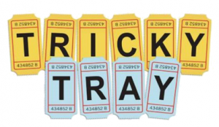

Enjoy an afternoon of fun, games, food and entertainment!

When: Saturday, October 29, 2022- 2:00-6:00 PM

Where: East Franklin Fire Station
121 Pine Grove Avenue
Somerset, NJ 08873

Cost: $25.00 per person (Includes Luncheon,
Chance to bid on Price is Right Showcases
20 Tickets for Tricky Tray
Benefit: Prostate Cancer research, screening and education.

Tickets go on sale September 1, 2022
For Tickets Call: 732-846-1380
NO TICKETS SOLD AT THE DOOR

No one under 18 will be admitted.
MUST BE PRESENT TO WIN PRIZES

Renaissance Cyclists Defeating Cancer United is a 501 (c) 3 Charitable organization.

